Group Assignment #3: Location Analysis

Logistics Management, Fall 2023

**Due: 23:30, November 21, 2023 (Tuesday)**

Aqua Hero is a big wholesaler distribution all kinds of drinks to many traditional grocery stores. The company is working on a project to determine the locations of its distribution centers (DCs) before it officially serve the market of Hsinchu County. The potential DC sites are shown in the following map. In the table, the data for each zone is listed. It has been estimated that each 1,000 people will lead to a transportation demand of 5 tons per year. The fixed cost for each potential site can also be found in the same table. It is assumed that the capacity of the DC is very big, and the associated capacity constraint can be ignored. The distance between each pair of zones (*dij*)[1] is provided in the data file on the E3 course platform. In addition, the unit trucking cost (per ton) is estimated to be about 15 TWD per km.

Your team is asked to prepare an executive summary for this location analysis project, and the following must be addressed in the report.

1. Determine the DC locations of the distribution system with the minimum total cost and describe the detailed information of your design (e.g. the assignment and the shares of cost components).
2. The company considers imposing a minimum distance (e.g., 25 km) from a DC to each of its associated market zones to ensure a good level of responsiveness. Thus, re-do the facility location analysis and evaluate the changes in cost and service quality.

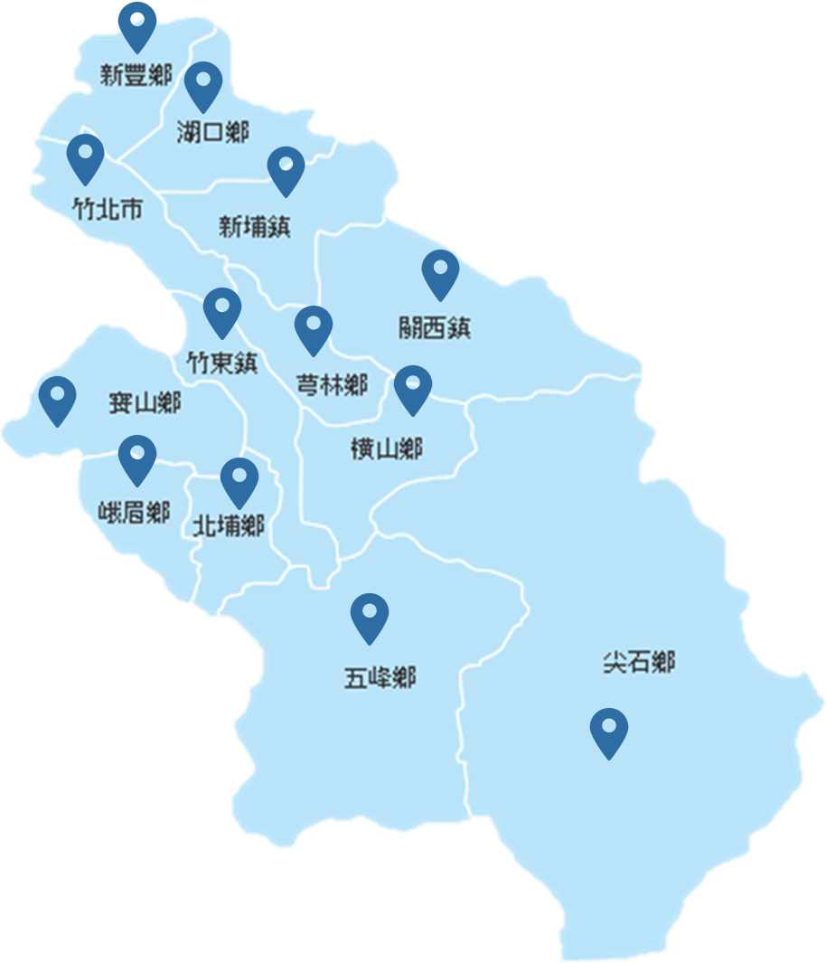 

1. The distances between the DC site and the demand node in the same zone is assumed to be 0 km as they can be relatively close to each other.